IMDb Movies & Directors Analysis
PRSQL-01
The dataset used in this project is based on IMDb movie and director information. It consists of two main tables:
- Movies Table (movies)
      - Contains details about films such as:
    - id (unique identifier for each movie)
    - title (name of the movie)
    - budget (production cost)
    - release_date (date the movie was released)
    - popularity (measure of audience interest)
    - vote_average (average rating given by viewers)
    - revenue (box office earnings)
👉 This table captures the commercial and critical aspects of movies.
- Directors Table (directors)
      - Contains information about film directors such as:
    - id (primary key, unique identifier for each director)
    - name (director’s full name)
    - gender (male/female/other)
    - department (usually “Directing”)
👉 This table provides demographic and professional details about directors.

🔗 Relationship Between Tables
- The movies table has a column director’s id that links to the id column in the director’s table.
- This relationship allows us to join both tables and analyse movies along with their directors.

🎯 Purpose of the Dataset
The dataset enables exploration of:
- Movie statistics (counts, popularity, revenue, ratings).
- Director information (names, gender distribution, productivity).
- Combined insights (e.g., which director made the most movies, which movies are most bankable, etc.).

📑 Problem Queries

1.Can you get all data about movies?
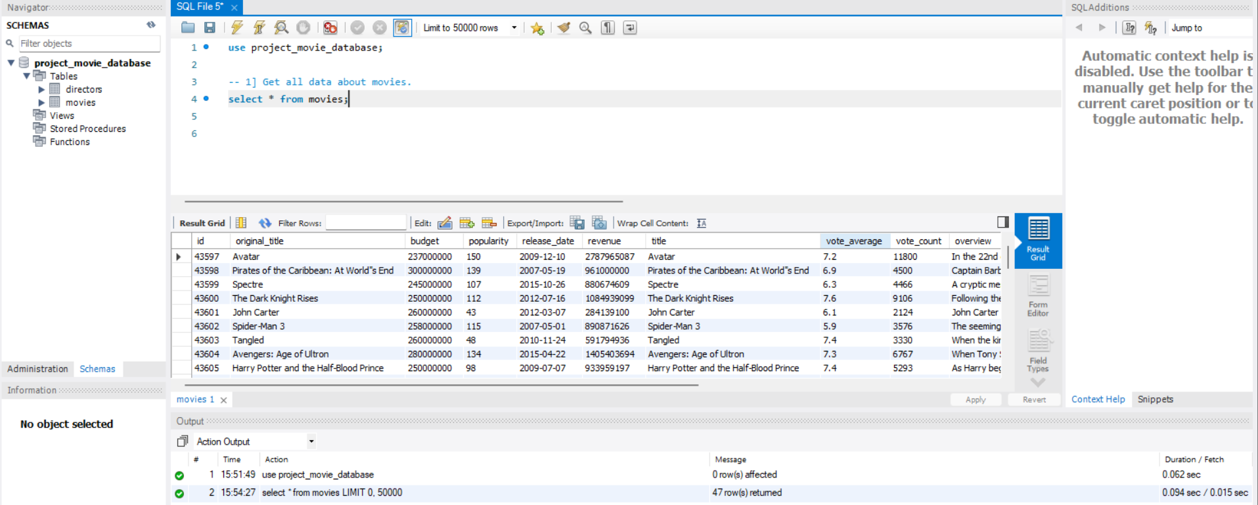
      - This query retrieves every column and row from the movies table, giving a complete overview of all movies in the dataset.

- How do you get all data about directors?

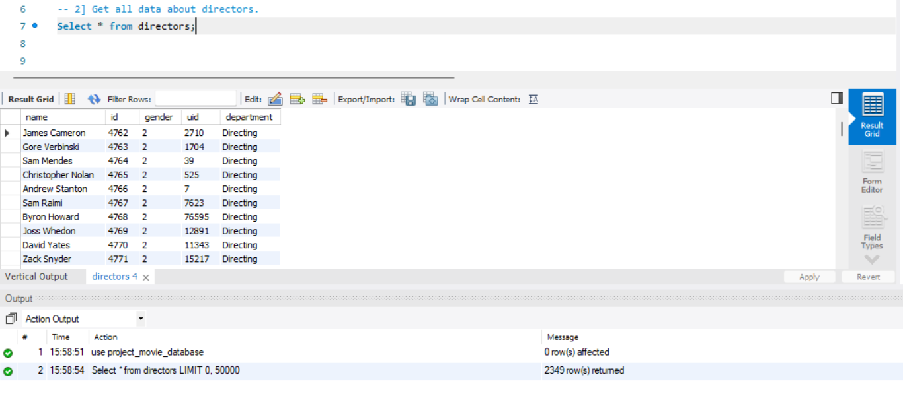
      - This query fetches all records from the directors table, showing details like director names, gender, and department.

- Check how many movies are present in IMDB?

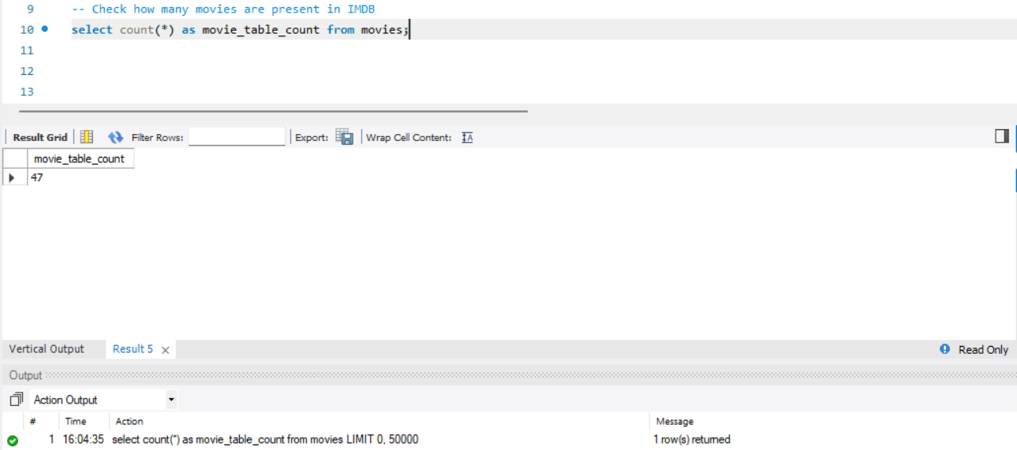

      - Using COUNT(*), we calculate the total number of rows in the movies table, which equals the number of movies stored.

- Find these 3 directors: James Cameron, Luc Besson, John Woo?

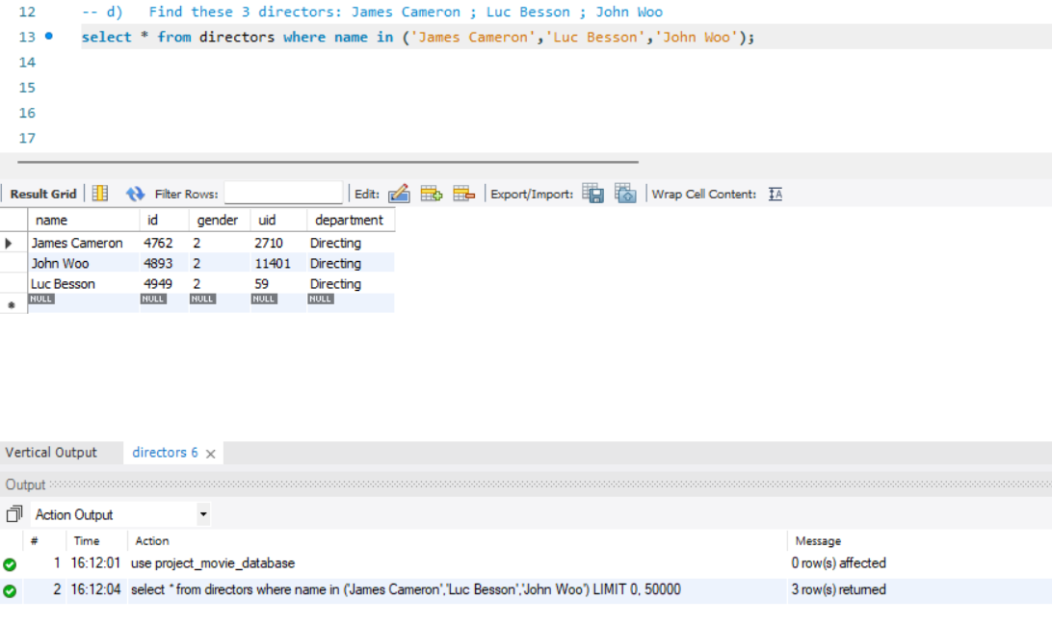
      - A WHERE name IN (...) filter is applied to the directors table to locate specific directors by name.

- Find all directors with name starting with S?
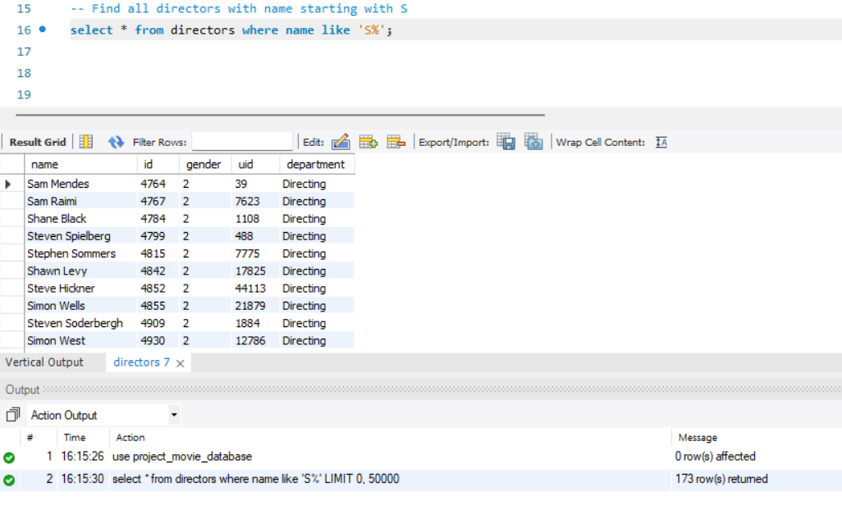
      - A LIKE 'S%' condition is used on the name column to return directors whose names begin with “S”.

- Count female directors?
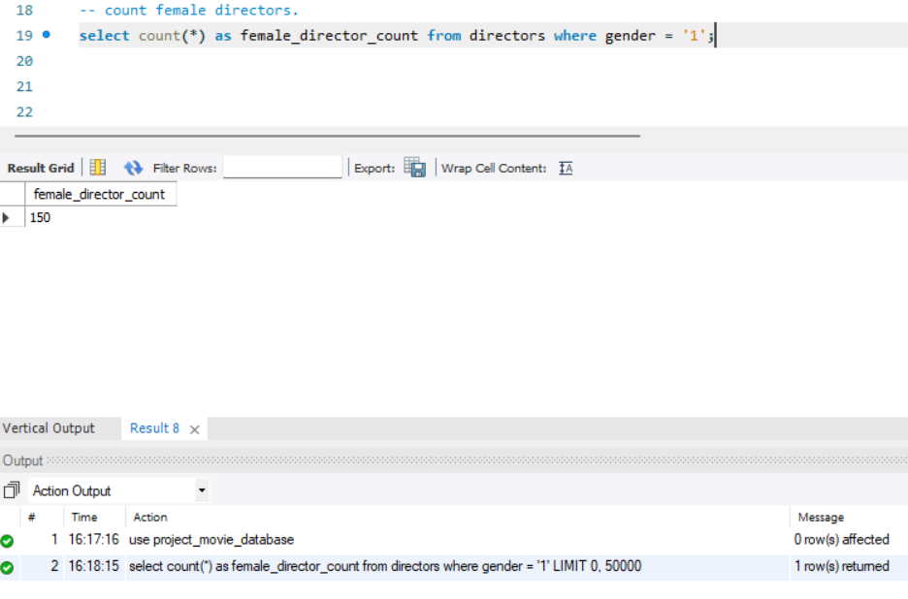
      - Filtering by gender = 'Female' (or gender = 1 depending on encoding) and applying COUNT(*) gives the total number of female directors.

- Find the name of the 10th first women directors?
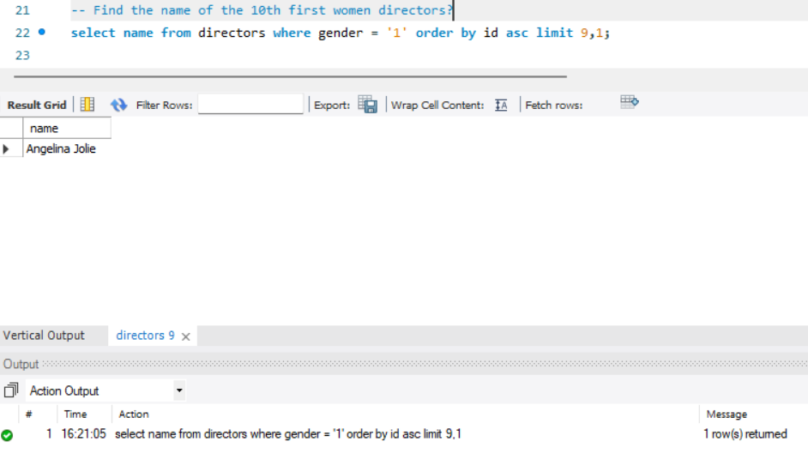
      - After filtering for female directors, we use ORDER BY name and LIMIT 1 OFFSET 9 to get the 10th entry alphabetically

- What are the 3 most popular movies?
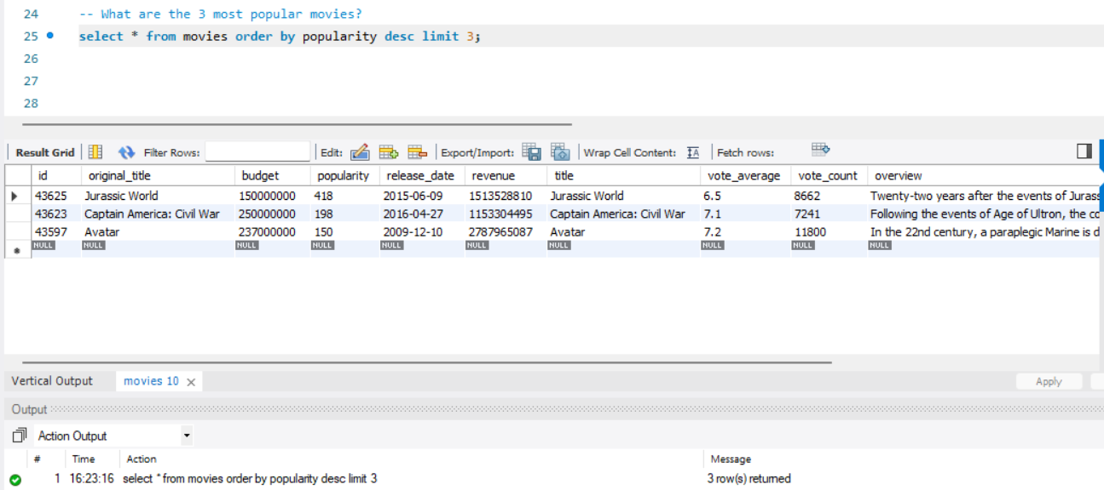
      - Sorting by the popularity column in descending order and limiting to 3 returns the top 3 most popular movies.

- What are the 3 most bankable movies?
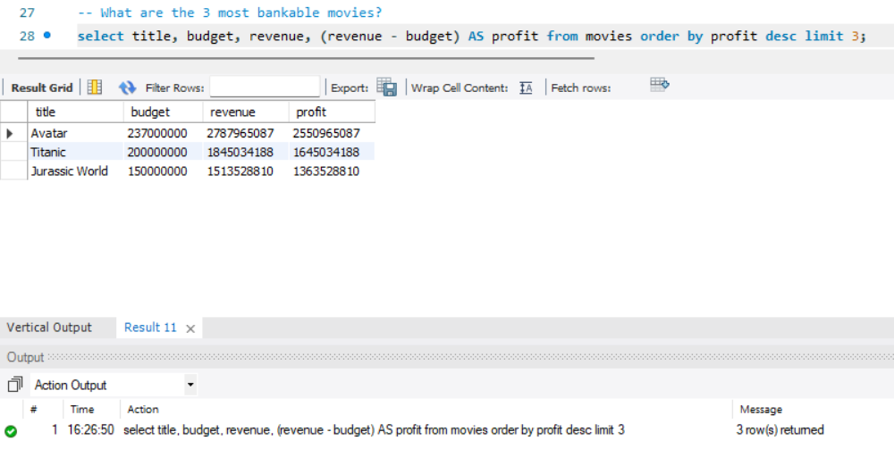
      - Sorting by budget or revenue (depending on dataset definition) in descending order and limiting to 3 shows the most financially significant movies.

- What is the most awarded average vote since the January 1st, 2000?
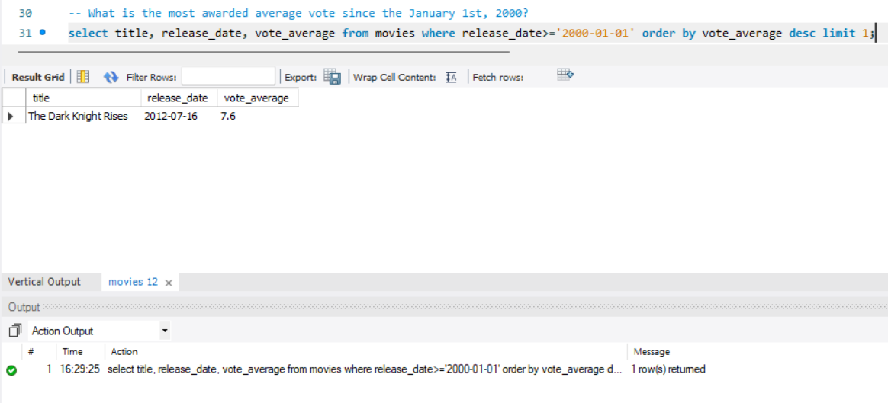
      - Filtering release_date >= '2000-01-01' and ordering by vote_average returns the highest-rated movie(s) released after 2000

- Which movie(s) were directed by Brenda Chapman?
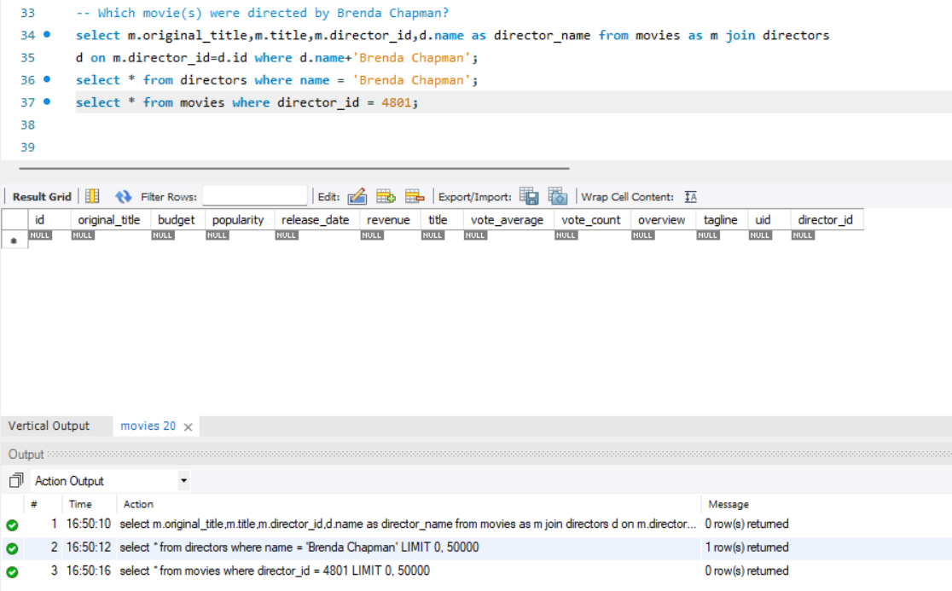
      - A JOIN between movies and directors using director_id = id and filtering name = 'Brenda Chapman' shows all her movies.

- Which director made the most movies?
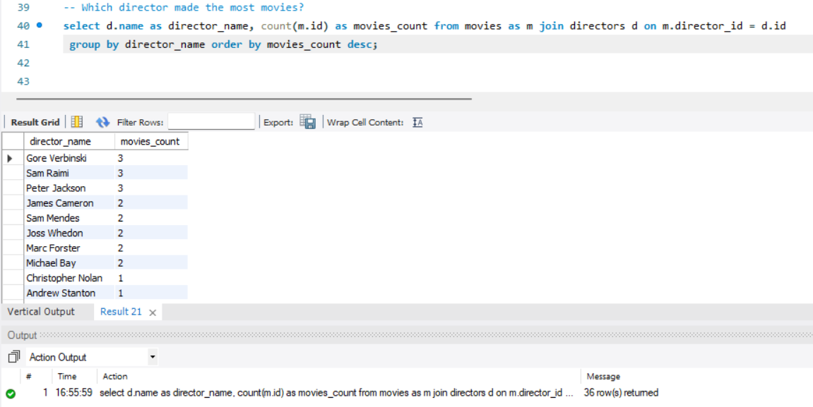
      - Grouping by director (GROUP BY d.name) and counting movies (COUNT(m.id)) identifies the director with the highest number of films.

- Which director is the most bankable?
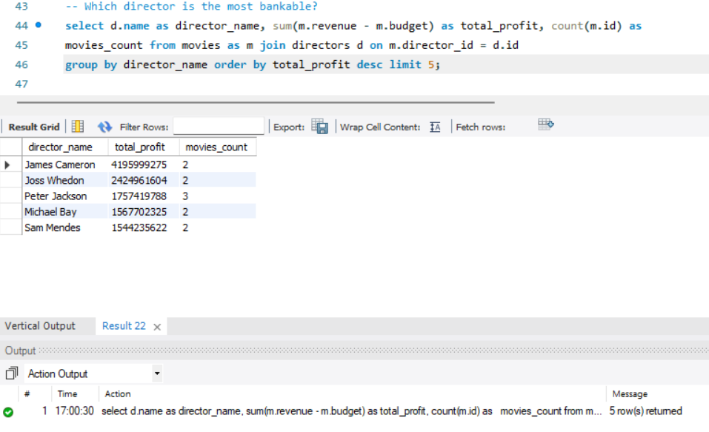
      - Summing up revenue or budget per director (SUM(m.revenue)) and ordering descending reveals the director with the greatest financial impact.

🏁 Conclusion

Through the problem queries, we explored the movies and director dataset in depth. By writing SQL queries, we were able to:
- Retrieve complete information about movies and directors.
- Perform counts and filters to understand dataset size and demographics.
- Identify specific individuals and their contributions.
- Analyse popularity, revenue, and ratings to find the most successful and bankable movies.
- Compare directors based on productivity and financial impact.
This project demonstrates how SQL can be used not only to extract data but also to generate insights about the film industry. The queries highlight the importance of joins, filtering, grouping, and aggregation in relational databases. Overall, the exercise shows how structured data can be transformed into meaningful information for analysis and decision-making.

Name: Pavithra S
Project ID: PRSQL-01
Team ID: PTID-CDA-SEP-26-11270 - CDA

